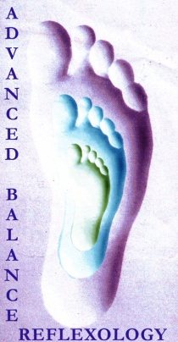 Certification Registration
Name:
Address:
Phone Number/s:
Email Address:
Are you a massage Therapist? (not required, this is just for my information)Y/N
This Class is Friday, May 5, 5:30-9:30pm, Saturday and Sunday, May 6 and 7, 9:30am-5:30pm at The Blue Ridge Center for Chinese Medicine, 144 Silver Maple Lane, Pilot, Virginia 24138
The cost is $350, which includes the future processing of documentation and exam and delivery of final certificate. Payment can be made via paypal to the email contact listed below. If you are repeating this same course with me, the cost is $175 (plus a $25 materials fee if you need a new booklet) Payment must be received at least 5 days prior to start date. There will be no refunds past April 21. Vouchers will be given for future classes if there is an emergency- limited to death in family, or doctor note or transportation failure on route to class) in those last two weeks keeping you from attendance. These vouchers are good for 2 years and participant is expected to travel to location of scheduled classes.
Please be aware that if you are receiving continuing education, you must attend all hours of the entire class and complete the at home documentation and exam portion of the course.
You will need to bring: one twin size set of sheets, one pillow with 2 pillow cases, a bath towel, pen or pencil, and a packed lunch or money to eat out for Saturday and Sunday. You are welcome to go to town for lunch, but be aware that it is a 15 minute drive and there is only 1 hour for lunch.
I have several massage tables so it is not a requirement, but please let me know if it is easy for you to bring a massage table to share for the class.
Thanks. Please email this form back to me. If you have any questions, please call or write:
Elisha Reygle 540-745-6789 or 540-629-3404 email: shamvara@yahoo.com

